(Approx. 962 words)

Adding Disk Space to Windows 7
By Dick Maybach
March 2012 issue, BUG Bytes, Brookdale Computer Users’ Group, NJ
www.bcug.com
n2nd (at) charter.net

When buying a new PC, it's usually wise to equip it with the largest possible hard disk.

Despite this, it's not uncommon to find that eventually it becomes uncomfortably full, leaving you with four options:
- save all your user data on an external disk, replace the system disk with a larger one, install Windows and all your applications from scratch, and restore your user data from the external disk,
- make an image of the current disk on an external drive, replace the current hard disk, and restore the image to it,
- add a hard disk and move some data folders to it, or
- enable dynamic disk management, which makes multiple disks appear as one, thus increasing the available space.

If your Windows 7 installation is corrupted by file system errors or malware, you must use option 1. If your system is working well, use option 2 (using the Windows 7 Backup and Restore tool), which is substantially easier and faster than 1. If your current system is working well, option 3 looks attractive, but there are significant issues, which I discuss below. I don't have the resources to test option 4, and I've learned from sad experience not to write about things I haven't done. If you are interested in dynamic disk management, see a good book, such as Window 7 In Depth by Cowart and Knittel. However, this approach appears to be complex enough to make it useful only in a professionally-staffed computer center. I don't recommend it for home users.

Option 3, add a second hard disk and move some of the data folders from our home folder to it, looks attractive. Here, some data will reside on a different drive, call it D:, and unfortunately, some programs, for example iTunes, cannot access data on it. You can edit iTunes' preferences to declare that, iTunes Media, the folder that holds its music, resides on D:, but iTunes apparently doesn't look outside your home folder. There are probably other applications with similar flaws.

A procedure called grafting appears to offer a solution. It maps all the files on an auxiliary disk into a folder in your home folder, and any files you later add to that folder are stored on the grafted disk. The basic procedure is as follows:
- copy all the files in the selected folder to the auxiliary disk;
- delete the selected folder on the main disk; and
- graft the auxiliary disk to a folder on main disk.

This indeed works on Windows 7, and after I did it, iTunes was able to find its files on the auxiliary disk, but operations were so flaky (see below) that I wouldn't do this on a PC that I actually used.

If you would like to experiment (not on the PC you use for TurboTax please), here is the procedure. Log into an account with administrator privileges, and open the Disk Management tool. (The easiest way is to tap the Windows key or click on Start, type “disk manage” and select Create and format hard disk partitions.) The screenshot below shows the result.
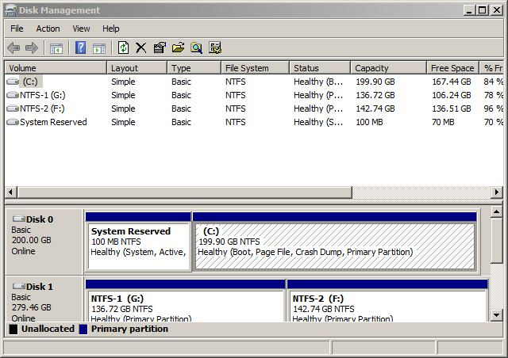

In this example, I graft NTFS-2 (F:) onto a folder in my home folder. Right-click on NTFS-2 (F:) and select Change Drive Letter and Paths … . Click the Add … button, select Browse … , navigate to the folder where the original folder appeared (in my case C:\users\n2nd), click the New Folder button. The result is shown below.
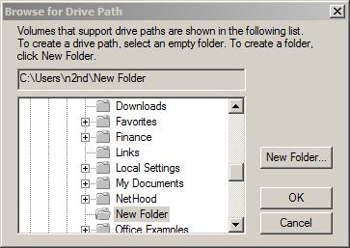

Click the OK button and the Browse for Drive Paths window will close, then click OK in the Add Drive Letter or Path window, and close the Disk Management window. The disk NTFS-2 (F:) is now grafted on the folder C:\Users\n2nd\New Folder. If you had to log in as a different user to obtain administrator privileges, log out and then log back into your home account, in my case n2nd.

This seems straightforward, but there are several traps. The Disk Manager is quirky and not well documented. I needed several attempts to make the above procedure work, which isn't good for a tool that modifies your folder structure. Since you can graft an entire disk only to a single folder, if there are several large folders, you must partition the auxiliary disk and graft a separate partition to each folder. This is unfortunate, because you can't graft your entire home directory, as it contains system files that are always in use. Most disturbing is that when I finished and tried to make a full backup, including a system image, the procedure failed. Even if it had succeeded, I'm not sure I could have restored my system. Would the software try to put everything on the original (now too small) C: disk, or would it be smart enough to restore to both C: and F: and graft F: to a folder? This isn't something about which you want to be surprised when you have to restore your files.

My conclusion after all this is that Windows 7 is designed to operate from a single disk, as are some of its applications. In this respect, it's made a step backward from XP, where you could locate your My Documents folder on any disk, and even iTunes could find its files there. You can add additional disks to a Windows 7 system, but accessing files on them will be somewhat less convenient than if everything resided in your home folder. As a result, if you run out of disk space on a Windows 7 PC, the best course is to replace the disk with a larger one and port your system to it.

